Tableau Dashboards Documentation

## **1. Analytics Team**

*Team members:* Anh Quan Hua

Xiaolu Li

Gouri Nandan Reddy Gangavaram

Nithini Bogahawattha

## **2. Introduction**

*Definitions*: Tableau Dashboards are condensed views comprised of several visualisations that attempt to assist users in rapidly grasping the primary insights to be displayed. Since our analysis report contains visualizations that might not be easily interpret to a wide range of viewers, our Tableau Dashboards are created to find the market gap and help our company to be more successful.

*Implementation*: Because of the way our datasets are built, it is critical to clean the data before utilising it to eliminate null and misleading data. Also, here I filtered out the list of activities that would be useful for us and for easier understanding and visualizing the no. of calories lost in that particular activity among those weight groups.

*Limitations*: Regardless of our results, Tableau is an excellent tool for creating meaningful infographics. The primary restriction here is first and foremost our team's Tableau competence since certain members only recently began to study and investigate Tableau at the start of the project. The second constraint is that the source data (csv files) retrieved from Kaggle may not be suitable for rapid visualisation in Tableau, necessitating additional analysis/processing.

*Data sources:* Fitness Trackers Products Ecommerce:

<https://www.kaggle.com/datasets/devsubhash/fitness-trackers-products-ecommerce>

## **3. Progress Update**

# **a. Data Cleaning & Visualization – Python Programming**

**Data used**: This is a fitness tracker product dataset for the Indian market that includes various products from various brands, along with their specifications, ratings, and reviews. The information was obtained by web scraping from an e-commerce website (Flipkart).

**Data Pre-processing:**

The input dataset is read and summary of the dataset is printed to visualize the information on each column. List of total number of null values are also checked before any further processing of the data. Reviews column is found to have the highest number of null values overall. Thereby removing this column to maintain consistency in the data.

1. **Importing packages used for data pre-processing:**

Here, all the packages required are imported for further using and the input csv data file is read using the python pandas packages “read_csv()”.

1. **Data Cleaning process:**

Here, the columns are checked for consistency in terms of having null values overall. And after processing it is found that the reviews column has over 80% null values and is hence dropped from the pandas data frame, without further processing.

Saving the final csv data into a csv file for that to be imported in Tableau and create visualizations for better understanding of the data for the success of the company.

1. **Data Visualization in Python – Alternative for Tableau:**

Here, using different python packages such as matplotlib & seaborn data can be visualized into different forms of graphs like bar-plot, pie chart, etc.

Above output shows the list of brands of fitness trackers which have an average battery life more than 10 days.

The above plot shows the Average battery life as a visual representation for easier understanding the average battery life offered by different company fitness bands or watches.

The above pie chart shows the total percentage of both fitness bands and watches records available in the overall dataset used as input.

# **b. Fitness Trackers Products – Tableau Dashboard**

**Link to public dashboard:** <https://public.tableau.com/views/Fitness_Trackers_Dashboard/Dashboard1?:language=en-US&:display_count=n&:origin=viz_share_link>

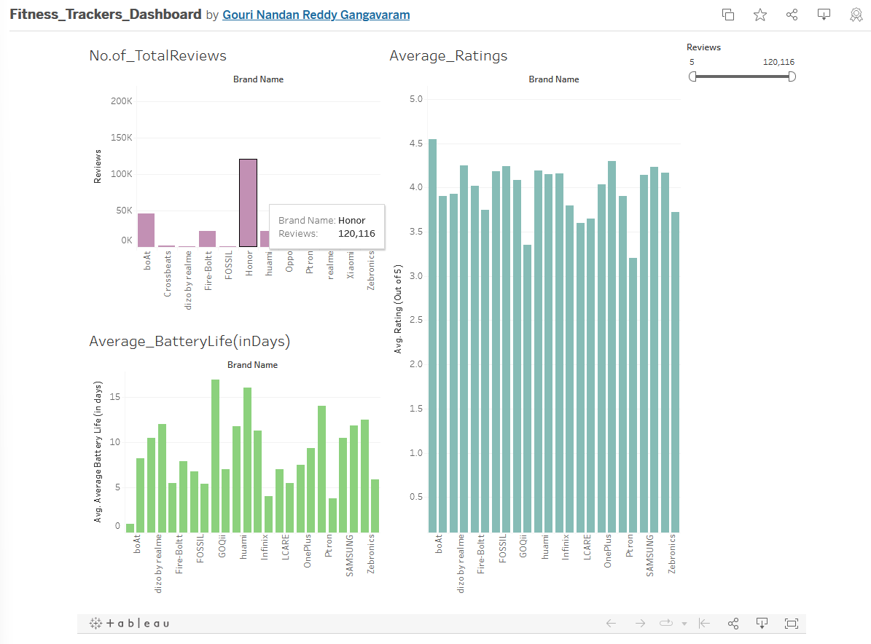

**Data used**: This is a fitness tracker product dataset for the Indian market that includes various products from various brands, along with their specifications, ratings, and reviews. The information was obtained by web scraping from an e-commerce website (Flipkart).

**Graph Details:**

*1st Graph:*

The 1st graph illustrates total no. of reviews for each brand of smart bands and watches over all combined in the entire dataset. This data could be proven useful as to knowing the current trend of watches and the number of people who are actually using the product on a daily basis to provide appropriate reviews on the watch or band.

*2nd Graph:*

The 2nd graph illustrates the Average Battery life of each of different bands or watches supplied or manufactured by different companies overall. The scale used here are labelled in terms of days for each company. This is very essential to visualize as majority of people may prefer having a good battery life for their watches and this might impact the overall sales of the company.

*3rd Graph:*

The 3rd graph illustrates the Average Ratings given by each reviewer for each company brand in terms of both fitness bands and smart watches. The scale of this ratings ranges from 1 to 5 where 1 being the lowest and 5 being the highest/best possible ratings. Visualizing this information is very crucial for having a successful business because ratings explain a lot about the quality and durability of the product and provide deeper understandings on how the product is impacting different users in their daily life and how useful it is. Both positive and negative ratings are to taken into consideration and act upon them for the next iterations of bands or watches.

